**Wireless Phone (4G)**

**User Manual**

appearance depends on the object

Model 1

Model 2

Model 3

**1. General Introduction**

Thank you for choosing our fixed wireless telephone. In order to use the phone better, please read this instruction carefully before use. The phone is designed using the latest 4G digital communication technology. Provides the following features:

Screen backlight, support night lighting

Two-way SMS, voice calls and caller id

Menu display

Store 800 contacts and 600 call logs for viewing and returning calls

Support 300 SMS messages

Support up to 10 ring tone options

Adjustable ring tone and volume

Support hands-free calls

Emergency call

Support charging status display

Support charger only

Long battery life, long talk time

Support CPE,WIFI hotspot

Support LAN wired routing (LAN port configuration needs to be turned on in Settings)

**2. Product overview**

**2.1 packing list**

Once you open the product package, please check the packing list to make sure there is no part missing. If any part is missing or broken, please contact the customer service. The packing list is as follow:

1 Phone Body

2 Handset

3.Coiled cord

4. Ni-MH Rechargeable Battery

5. AC Adaptor

6. Charging line with USB port

7. User Manual

**2.2 product introduction**

**2.2.1 appearance**

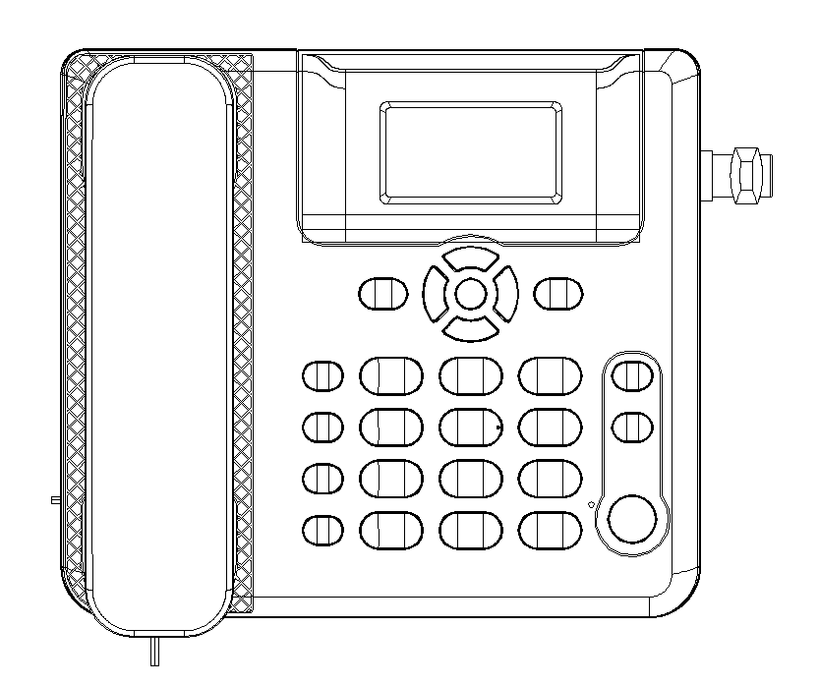

**2.2.1.1 schematic diagram of the front:**

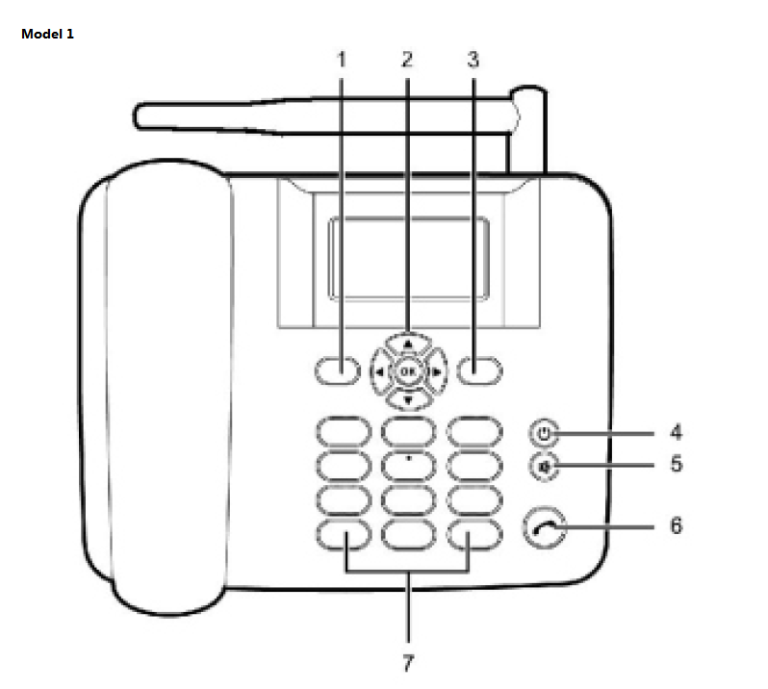

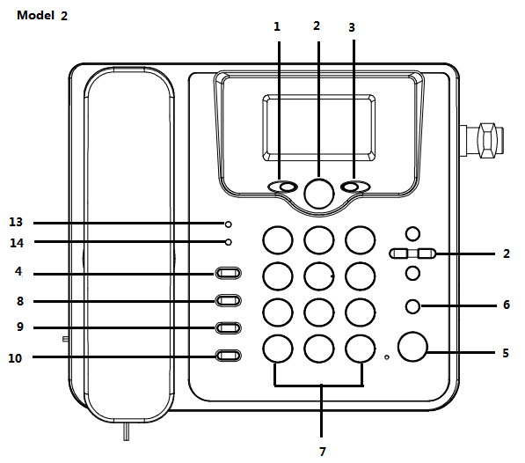

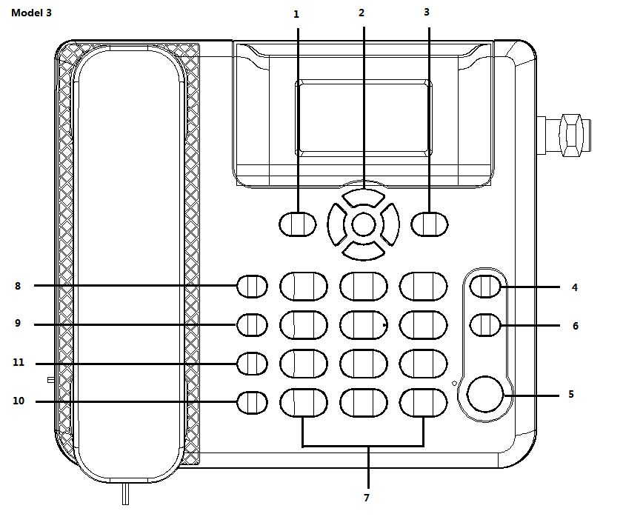

1. left function key · in standby mode, press this button to enter the main menu

 · press this button to select the menu or operation corresponding to

the text on the left side of the bottom of the screen

1. direction key · in standby mode, press OK to enter the main menu

 · in standby mode, press the arrow keys to enter the corresponding

shortcut menu

· in the call state, press the direction button to adjust the call volume

1. right function key

 · press this key to select the menu or operation corresponding to the

text on the right side of the bottom of the screen

1. end key **·** Close the call or reject the call

** ·** long press this button to turn on or off

· in non-standby state, press this button to return to standby state

1. hands-free key · in standby mode, press this button to use speakerphone to make or

 receive calls

· press this button to cancel or end a call in hands-free mode

1. speaking key · make or receive calls

 · in standby mode, press this button to check the call record

1. number and symbol keys

· enter Numbers or characters

· in standby mode, long press 1-9 number keys for speed dial

· in edit state, press # key to switch input mode

· in edit mode, press * to open the symbol list

1. WIFI key · in standby mode, press this button to enter the Wi-Fi menu
2. SMS key · in standby mode, press this button to enter SMS menu
3. redial key · in standby mode, press this button to redial the last call
4. setting key · in standby mode, press this key to enter the Settings menu
5. call log key · in standby mode, press this button to enter Calls menu
6. hands-free light ·In hands-free mode, the light turns on  
    ·exit hands-free mode, the light turns off
7. power light · When AC adaptor is connected and powered, the light is turned on

**2.2.1.2 schematic drawings of back and side**

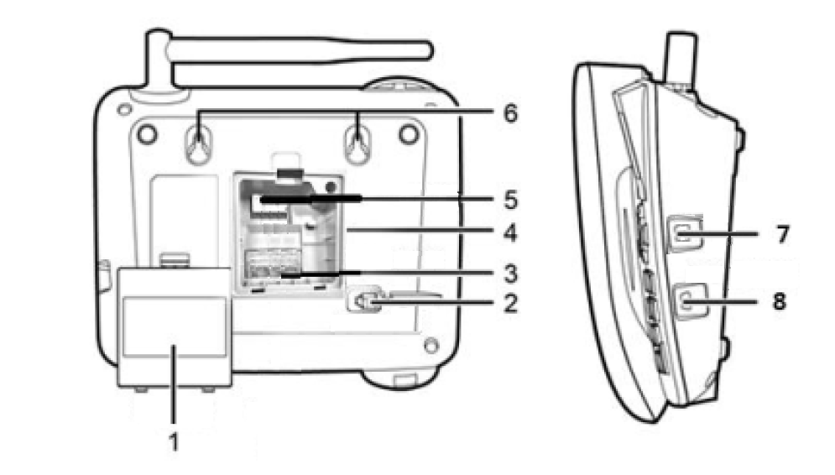

1. The battery door
2. Handle wire socket
3. SIM card slot , and tf card slot in some models
4. Battery compartments
5. Battery cable slot
6. The hanging wall hook
7. LAN port
8. USB charging port

**2.2.1.3 Display icons**

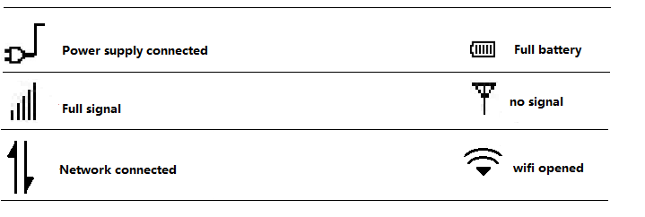

**2.2.2 menu tree**

|  |  |  |
| --- | --- | --- |
| **Messages** | **Contacts** | **Calls** |
| **New message**  **Inbox**  **Outbox**  **Draftbox**  **Sentbox**  **Settings**  **Memory info** | **New**  **View**  **Edit**  **Call**  **Send Message**  **Send SMS VCard**  **Delete**  **Mark**  **Copy to USIM**  **Move to USIM**  **Add/Remove Black list**  **Add/Remove White list**  **Memory in use**  **Capability**  **Speed dial** | **All**  **Missed**  **Dialed**  **Received** |
| **Tools** | **Settings** | **Wi-Fi** |
| **Calendar**  **Alarm**  **Calculator**  **STK**  **Weather** | **Sound Settings**  **Display**  **Phone Settings**  **Call Settings**  **Network Settings**  **Security Settings**  **Factory Reset** | **Wi-Fi Switch**  **Wi-Fi Config**  **Device List** |

**3. Safety information**

Before using and operating the equipment, please read and follow the following precautions to ensure the best performance of the equipment and avoid dangerous or illegal situations.

**Electronic equipment**

* Do not use the wireless equipment in the places where there are explicit rules against using the wireless equipment, otherwise it will interfere with other electronic equipment or cause other dangers.

**Impact on medical devices**

* In medical and health care Settings where wireless devices are expressly prohibited, please follow the site's rules and turn off the devices.
* The radio waves generated by the device may affect the normal operation of implantable medical devices or personal medical devices, such as pacemakers, cochlear implants and hearing AIDS. If you use any of these medical devices, consult their manufacturer about restrictions on their use.
* When using this device, keep at least 15cm away from the implanted medical devices (such as pacemakers, cochlear implants, etc.).

**Flammable and explosive area**

* Do not use this device in gas station (service station) or near inflammable and explosive dangerous area, and follow all graphic or text instructions. Equipment may cause an explosion or fire in or around areas where fuel or chemical agents are stored and transported or explosive sites.
* Do not store or transport the equipment and its accessories in the same box with flammable liquids, gases or explosive substances.

**The traffic safety**

* Comply with the relevant regulations of the region or country. Do not use this device while driving.
* Remember that safe driving is your first duty. Do not engage in distracting activities.
* Please use the hands-free function while driving. Do not hold the device.
* Suggest pulling over to the side of the road and then making or receiving the call.
* The car's electronics may malfunction due to radio interference from the equipment. Please contact the manufacturer for details.
* Do not place the device on top of the car airbag or within the area that can be reached after the airbag is deployed. Otherwise it's an airbag
* When inflated, the device will be pushed by a strong external force and cause serious damage to the occupants of the vehicle.
* Wireless devices may interfere with the aircraft's flight system. Please comply with the relevant regulations of the airline. Do not use this device where wireless devices are prohibited.

**The operating environment**

* Do not use the device in the place where it is dusty, damp or near the magnetic field, in order to avoid causing circuit failure.
* Stop using the device and disconnect the power supply before plugging and unplugging the cable. Keep your hands dry when reconnecting the cables.
* Please place the equipment on a stable bench.
* When placing equipment, stay away from electrical appliances with strong magnetic field or electric field, such as microwave oven, refrigerator, etc.
* During lightning, please disconnect the power supply and unplug all cables connected to the equipment to avoid damage caused by lightning.
* Do not use this equipment during thunderstorm. Thunderstorms can cause equipment failures or electric shock hazards.
* Please use the equipment in the range of 0°C -+45°C, and store the equipment and its accessories in the range of -20°C-+70°C. Equipment failure may occur when the temperature is too high or too low.
* Please place the equipment or its accessories in a ventilated, cool environment without direct sunlight. Do not wrap, seal or cover the equipment with towels or other items. Do not place the equipment in the sealed environment such as boxes and boxes, so as to avoid damage to the equipment due to poor heat dissipation.
* Do not place the device in direct sunlight, such as the dashboard or window sill.
* Please avoid the equipment and its accessories from rain or damp, or it may cause fire or electric shock hazard.
* Do not put the equipment near a source of heat or exposed fire, such as electric heaters, microwave ovens, ovens, water heaters, fires, candles or other places that may produce high temperatures.
* Do not place any objects (such as candles, water containers, etc.) on the equipment. If any foreign matter or liquid enters the equipment, please immediately stop using and disconnect the power supply.
* Do not use any object to block the opening of the device, and leave more than 10 cm of heat control around the device.
* Do not place sharp metal objects, such as pins, near the handset or loudspeaker of the equipment, so as to avoid the attachment of metal objects and harm to you.
* The temperature of the equipment will rise after running for a period of time. If the equipment temperature is too high, do not contact it for a long time, otherwise it may cause low temperature scald, skin redness and swelling or pigmentation.
* Do not touch the antenna when using the device. Touching the antenna will affect the communication quality.
* Do not allow children or pets to bite or swallow the equipment or its accessories in case of injury or failure or explosion of the equipment.
* When using the equipment, be sure to keep a distance of more than 20cm between the body and the antenna.
* Try to place the device in a position where the network signal is well received. The distance between the equipment and other metal objects (such as metal brackets, metal doors and Windows, etc.) should be more than 25 centimeters, and the distance between multiple devices should be more than 30 centimeters.

**Children's health**

* This equipment and its accessories may contain some small parts. Please keep the equipment and its accessories out of the reach of children. Children may inadvertently damage the equipment and its accessories, or swallow small parts resulting in suffocation or other hazards.
* This device is not a toy. Children should use it under adult supervision.

**Accessories for**

* Using an unapproved or incompatible power supply, charger or battery may cause fire, explosion or other hazard. Only accessories approved by the equipment manufacturer and compatible with this type of equipment can be used. If other types of accessories are used, it may violate the warranty terms of the equipment and the relevant international regulations of the equipment, and may lead to safety accidents. For approved accessories, please contact authorized service center.

**Charger safety**

* When charging the device, the power socket should be installed near the device and should be easily accessible.
* Disconnect the charger from the device and unplug the charger from the power socket when it is fully charged or not charged.
* Do not fade or collision charger. If the charger case is damaged, please contact the authorized service center for replacement.
* If the charger plug or power cord is damaged, do not continue to use it to avoid electric shock or fire.
* Do not touch the power cord with wet hands or pull out the charger by pulling the power cable.
* Do not touch the device or charger with wet hands to avoid short circuit, fault or electric shock.
* When the charger is soaked by rain, liquid or seriously damp, please stop using it and contact the authorized service center for replacement. The charger must meet the requirements of "2.5 limited power supply" in the standard GB4943.1 information technology equipment safety. IF the device needs to connect to a USB port, make sure the USB port has the usb-if identification and its performance conforms to the relevant specifications of usb-if.

**The battery safety**

* Do not connect the metal conductor with the battery pole, or contact the end of the battery, in order to avoid battery short circuit, and battery overheating caused by burns and other physical injuries.
* Do not expose the battery to high temperature or around heating equipment, such as sunshine, heater, microwave oven, oven or water heater. Overheating of the battery may cause an explosion.
* Do not disassemble or modify the battery, insert foreign matter, or immerse in water or other liquid to avoid battery leakage, overheating, fire or explosion.
* If the battery leaks, do not expose the skin or eyes to the leaking fluid. In case of contact with skin or eyes, rinse immediately with water and go to hospital for medical treatment.
* If the battery has discoloration, deformation, abnormal heat and other abnormal phenomena during use, charging or storage, please stop using and replace the battery.
* Do not throw the battery into the fire, or it will cause fire and explosion.
* Please dispose of batteries according to local regulations. Batteries are not allowed to be disposed of as household waste. Batteries can explode if not properly disposed of.
* Do not allow children or pets to swallow or bite the battery in case of injury or battery explosion.
* Do not drop, squeeze or puncture the battery. Avoid putting too much external pressure on the battery, which can short-circuit and overheat the battery.
* Do not use damaged batteries.
* When the standby time of the device is significantly shorter than normal, replace the battery.

**Maintenance and upkeep**

* During storage, transportation and use of the equipment, please keep the equipment dry and avoid violent collision with other objects.
* Please keep the equipment and accessories dry. Do not dry them with external heating equipment such as microwave oven or hair dryer.
* Do not place the equipment and its accessories in an area where the temperature is too high or too low, otherwise the equipment may malfunction, catch fire or explode.
* Do not make the equipment and its accessories subjected to strong impact or vibration, so as to avoid damage to the equipment and its accessories, leading to equipment failure.
* When the device is not in use for a long time, disconnect the power supply and unplug all cables connected to the device.
* In case of smoke, abnormal sound, peculiar smell and other abnormal phenomena, please immediately stop using and disconnect the power supply, unplug all cables connected to the equipment, and contact the authorization service center.
* Do not step on, pull or bend the equipment cable excessively, in case the equipment is not working normally.
* Before cleaning and maintenance, please stop using the device, close all applications, and disconnect all connections or cables from other devices.
* Do not use strong chemicals, cleaning agents or strong detergents to clean the equipment or its accessories. Use a clean, dry soft cloth to wipe the equipment or its accessories.
* Do not contact the magnetic stripe card (such as bank card, telephone card, etc.) with the device for a long time, otherwise the magnetic stripe card may be damaged by the magnetic field.
* Do not disassemble or modify the equipment and accessories without authorization, otherwise the equipment and accessories will not be covered by the company's warranty, please contact the authorized service center when the equipment fails.
* If the screen is partially broken due to the collision of the device with hard objects or strong impact from the outside world, do not touch or try to remove the broken part, please stop using it immediately and contact the authorized service center in time.

**Emergency call**

* The success of emergency calls depends not only on network conditions, but also on local operators and regulations, so in some areas or situations, equipment may not be available for emergency calls. Therefore, in an emergency, do not rely on this device to achieve important communications such as medical aid.

**The environmental protection**

* Do not treat this equipment and its accessories as ordinary household garbage.
* Please comply with the local laws on the disposal of this equipment and its accessories and support the recycling action.

**4 legal declaration**

All rights reserved.

With the written consent of the company, no unit or individual shall arbitrarily extract or copy part or all of the contents of this manual, and it shall not be disseminated in any form.

Products described in this manual may contain software copyrighted by the company and its possible licensors. Unless with the permission of the relevant owner, no one may copy, distribute, modify, extract, decomcompile, disassemble, decrypt, reverse engineer, lease, transfer or other ACTS infringing the software copyright in any form, unless such restriction is prohibited by the applicable law.

Other trademarks, product names, service names and company names appearing in this manual and the products described in this manual shall be owned by their respective owners.

Pay attention to

Certain features and functions of the products and accessories described in this manual depend on the design and performance of the local network and the software you install. Some features and functions may not be supported by your local network operator or Internet service provider, or by your local network Settings, or by the software you install. Therefore, the description in this manual can be

Can you buy products or its accessories are not completely one-to-one correspondence.

The company reserves the right to modify any information in this manual at any time without prior notice and without any liability.

**Limitation of liability**

The contents of this manual are provided 'as is' and unless required by applicable law, the company does not provide any warranty, express or implied, on all contents of this manual, including but not limited to warranties of merchantability or fitness for a particular purpose.

To the extent permitted by applicable law, the company shall not, under any circumstances, compensate for any special, incidental, indirect or secondary damages caused by the use of the relevant contents of this manual and the products described in this manual, nor for any loss of profits, data, goodwill or anticipated savings.

To the extent permitted by relevant laws, in any case, the company's maximum liability for any loss suffered by you as a result of using the products described in this manual (except for damages stipulated by applicable laws in the case of personal injury) shall be limited to the price paid by you for purchasing the products.

**Import and export control**

If you need to export, re-export or import the products described in this manual (including but not limited to the software and technical data in the products), you shall comply with the applicable import and export control laws and regulations.

**Warranty service policy**

The company's products purchased by consumers through legal channels, such as non-human damage to the performance of the fault, in strict accordance with the national three-pack service policy.

Maintenance record

|  |  |  |  |  |
| --- | --- | --- | --- | --- |
|  | The fault phenomenon | The maintenance method | Send a date | Signature of maintenance personnel |
| Maintenance record 1 |  |  |  |  |
| Maintenance record 2 |  |  |  |  |
| Maintenance record 3 |  |  |  |  |

Warranty card (user stub)

|  |  |
| --- | --- |
| User name: | Contact number: |
| Mailing address (including postal code) : | |
| Product model: | Serial number (SN) : |
| Purchase date: | Invoice no. : |
| Name of selling unit (with official seal) | |
| Address of selling machine (including postcode) | |
| Phone number: | |

Note: this card is the basic certificate of warranty, please fill in carefully and keep it properly.

1. This warranty card is only applicable to the host with the serial number listed above and the three-pack service of accessories.

2. Please bring the original warranty card and invoice for maintenance (the warranty card and invoice must be completed and stamped with official seal by the seller, and shall not be altered, otherwise it will be invalid). Please note that the maintenance service center shall provide a complete maintenance record sheet.

Warranty card (company stub)

|  |  |
| --- | --- |
| User name: | Contact number: |
| Mailing address (including postal code) : | |
| Product model: | Serial number (SN) : |
| Purchase date: | Invoice no. : |
| Name of selling unit (with official seal) | |
| Address of selling machine (including postcode) | |
| Phone number: | |