**QUICK INSTALLATION GUIDE**

**R102VE 2.4G only 4G LTE CPE**

**Conventions**

Thank you for purchasing R102VE 2.4G only 4G LTE CPE.

Application to 4G wireless router, this installation guide provides a Web-based configuration guide method and procedure.In this guide, Windows 10 is used as an example.

**Interfaces**

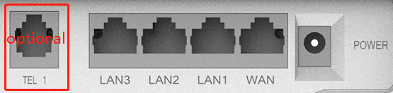

|  |  |  |  |
| --- | --- | --- | --- |
| **Interfaces** | **Interfaces description** | | **Functional description** |
| Power | DC 12V port | | Prevent surge, prevent reverse connection |
| Network | Four RJ45 network ports | WAN | RJ45 port，Connect to an external network to allow the device to be wired to the network |
| LAN1/LAN2/LAN3 | Terminal equipment for connecting RJ45 network port such as computes |
| TEL(optional) | RJ11 port，Connect a home phone line |
| Antenna | Two 2.4G WIFI antenna  Two 4G antenna | | Responsible for sending and receiving electromagnetic radiation from the air |
| Button | Power button | | Self-locking switch，Control device startup and shutdown |
| Reset button | | Reset and restart Equipment system |
| WPS button | | WPS long press to restore factory settings |

**Specifications**

Supply voltage：DC 12V

**Working Environment**

Working temperature and humidity：-30℃~+70℃ 10%~90%RH non-condensing，Storage temperature and humidity：-35℃~+80℃ 5%~90%RH non-condensing。Therefore,in order to ensure the normal operation of the device,the recommended working environment of the device is as follows:

Keep away from heat and keep ventilated

Place the device in a ash-free and dry environment

In thunderstorm weather,please remove the power supply and all connections of the equipment to avoid damage by lightning.

According t the installation method(handing ears or rail clips),place the device on a flat surface

**LED Lights Indicators**

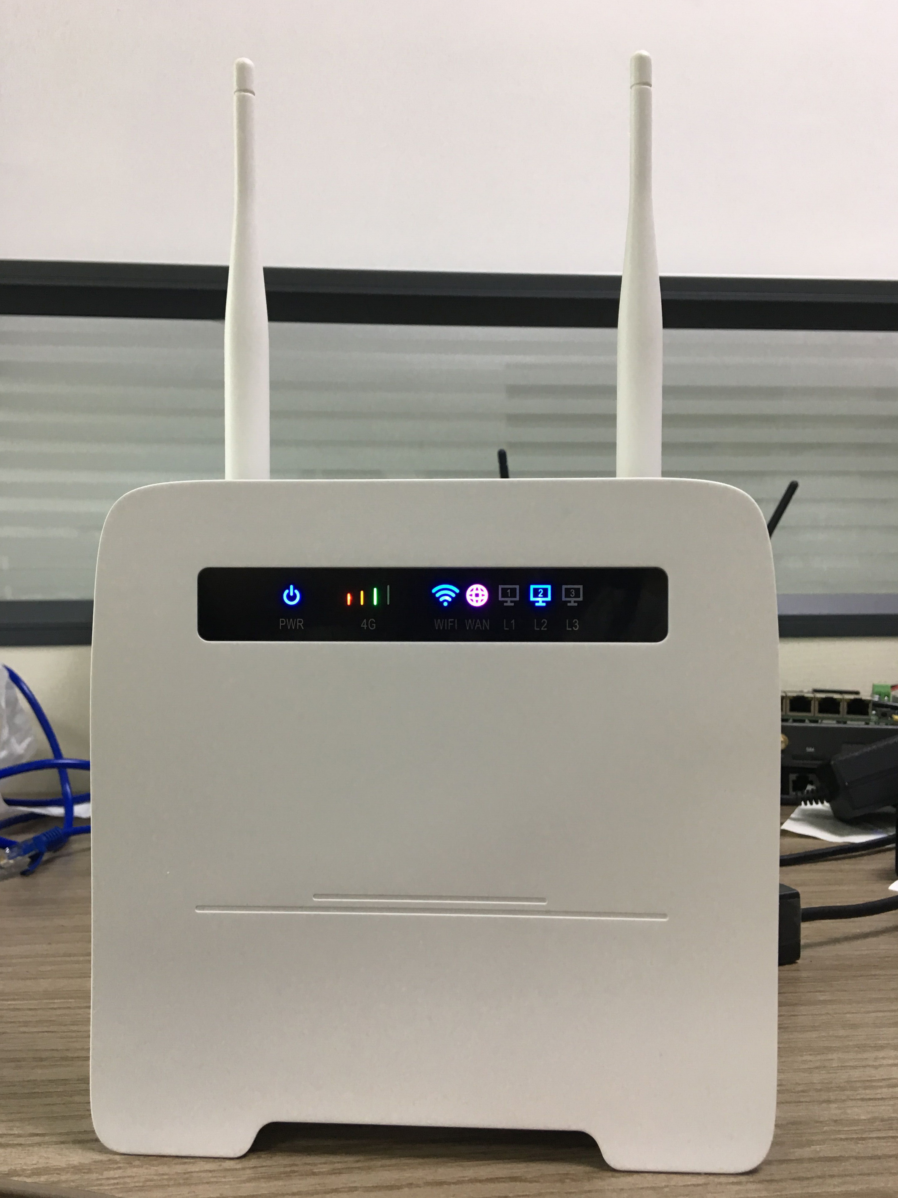

|  |  |  |
| --- | --- | --- |
| **Indicator coordinates** | **Meaning** | **Description** |
| [IMG_256](https://www.easyicon.net/1225484-off_on_power_shutdown_switch_icon.html) PWR | Always on | System started up and in working state |
| [IMG_256](https://www.easyicon.net/1102974-signal_icon.html) 4G | Light on  Based on signal strength | 4G signal is normal. The four-grid signal corresponds to four indicator lights, which are all on when the signal is full |
| Light off | 4G off-line or WAN network online |
| wifi Wi-Fi | Always on | Wi-Fi working |
| Flashing | Data is being received or sent via WLAN |
| Off | Wi-Fi disable |
| [IMG_256](https://www.easyicon.net/1225510-global_internet_web_world_www_icon.html) WAN | Blue Always on | Connect to the Internet via Ethernet |
| Flashing red | LTE Mode, No Service or Sim Card Error |
| Flashing Green | LTE Mode, device is connected to the Internet， |
| Flashing red and Green | LTE Mode, Dialing up |
| LAN1/LAN2/LAN3  1590111632(1)/ 1590111632(1)/ 1590111632(1) | Always on | An Ethernet cable is connected to the LAN port properly |
| Flashing | Data is being received or sent through the LAN port |

**Equipment List**

R102VE CPE✖1 2.4G Wi-Fi antenna✖2 4G antenna✖2

DC 12V Power adapter✖1 Quick start guide✖1

**Device Configuration instructions**

**nfiguration Instructions**

If you need to manage and configure this device, you can connect to the 4G LTE CPE wireless or by wire. The default 4G LTE CPE address of this device is 192.168.169.1 and the sub-net mask is 255.255.255.0. These network parameters can be modified according to the actual situation, which will be explained with default values.

**Log in to the background management interface**

After the R102VE device is powered on, users can use their mobile phones or tablets to connect to the device’s wireless Wi-Fi. The Wi-Fi name is ”R102E-2.4GHz-××××××”,and the Wi-Fi factory password is 12345678.Users can also directly connect the LAN port of the R102E LTE CPE device to the computer network port using a network cable.

1. Open the IE of the computer or smart-phone/tablet, type the address bar:192.168.169.1 in the address bar, and press Enter.



1. In the pop-up login window, enter the password :admin; then click ”Login”(or enter password and press Enter directly to enter).

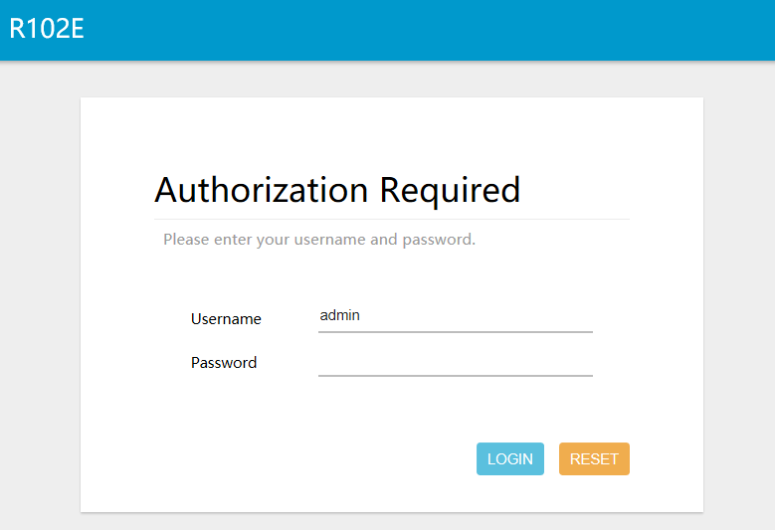

NOTE：The initial administrator passwords are all “admin”, users can change the administrator password after entering the configuration system.

1. After entering the correct password, you can enter the device’s WEB configuration interface “Overview” view.

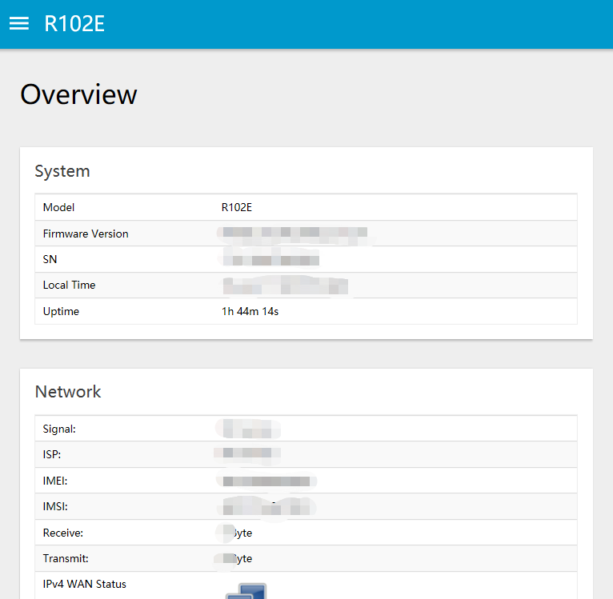

**Working Mode Setting**

The R102VE LTE CPE supports five Internet access modes: DHCP (Dynamic Host Configuration Protocol)Internet, Wired Bridge, STATIC(Static Host Configuration Protocol), PPPOE(point-to-point Protocol Over Ethernet), Wireless 2.4G Client, Wireless 5G Client, 4G LTE. The default external network connection mode is "wireless 2.4GHz access". Users can click the "Network 🡪 WAN" in the navigation bar to enter the extra-net connection settings, and then click the "Connection Type" drop-down button to select the Internet mode that they want.

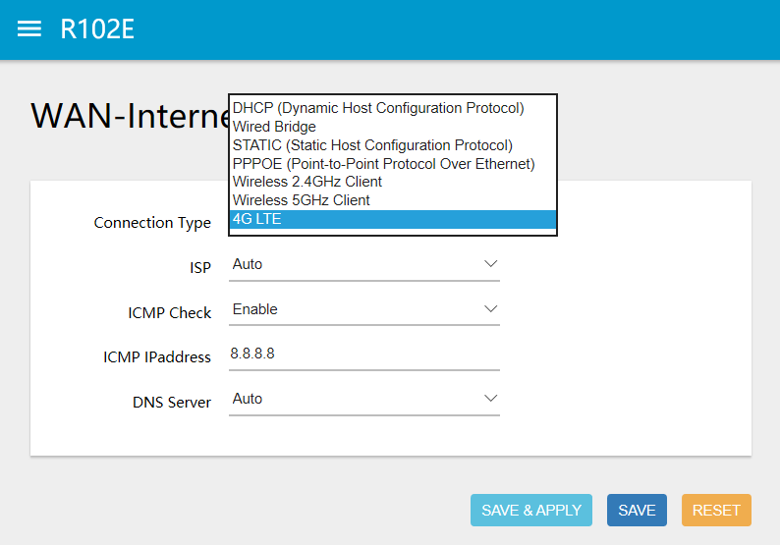

1. **Gateway Mode**

Like other home routers .It’s WAN port is connected to broadband, and the other three are LAN ports. The connection methods include DHCP dynamic Internet access(automatic acquisition), PPPOE dialing, and static IP Internet access three ways. Will act as a wireless (or wired) access point, bridge to your local network and connect to the Internet through a router.

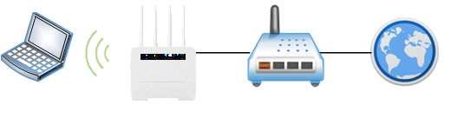

(Network map settings link diagram)

1. **4G LTE Mode**

CPE starts the default mode, inserts the SIM card to use the 4G module to surf the Internet, and all the net ports are LAN ports.

1. **Wireless Relay Mode**

After opening the LTE CPE, use the wireless network card to relay other Wi-Fi signals to access the Internet.

1. **Access Point Mode**

When turned on, the CPE is a wireless switch(no IP address is assigned)that can be wired in series (to any network port)to achieve a two-tier connection between wired and wireless network under other routers.

1. **Wireless 2.4GHz Setting**

In the default mode of R102VE start-up, the user can click on the "Bar 🡪 Wireless 2.4GHz" in the navigation bar to enter the wireless network settings, then click the "SSID" blank bar to change the setting WIFI name, click the "Password" blank bar can modify the WIFI password.

**Device Management**

1. **Administration**

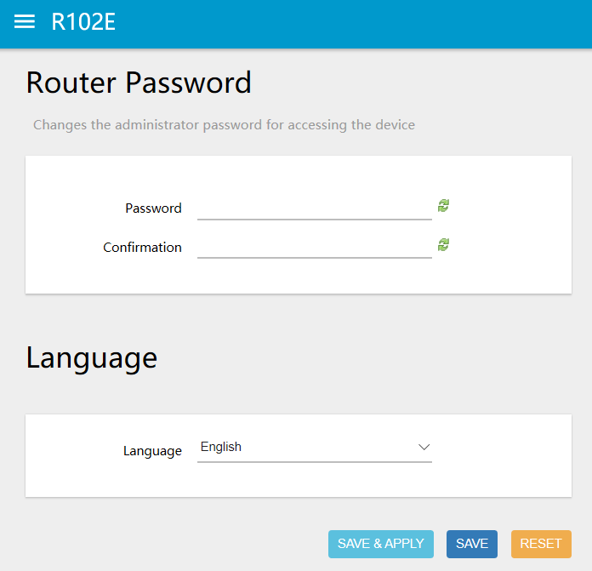

Set the login password of the device background management interface in the “Router Password” bar. Select language in “language” bar.

1. **Restore**

Click “PERFORM RESET” Let the device restart.

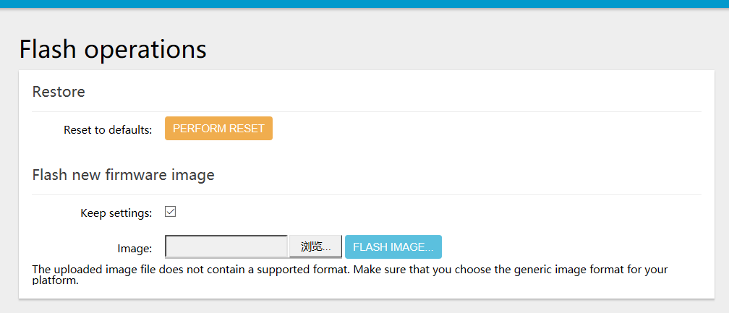

1. **Software updating**

Users can click the "System 🡪 Restore/Flash Firmware" in the navigation bar to enter the flash new firmware image settings, with software upgrades, you can load the latest version of the software to the router for more functionality and more stable performance Steps as below:

1. Save the upgrade file to local computer.
2. Click “browse button”, then select the upgrade file which you save , form the local to upgrade, select software that needs upgrading.
3. Click “FLASH IMAGE...”.

